AI-Enabled Student Admissions & Support Management System
Salesforce CRM Project Report
Submitted By
Name: Pardha Saradhi Jonnadula
Course: Bachelor of Technology (B.Tech)
Branch: Computer Science & Engineering
College: PSCMR College of Engineering & Technology
Platform
Salesforce CRM
Project Type
AI-Enabled Salesforce Application

1. Project Overview
The AI-Enabled Student Admissions & Support Management System is a Salesforce-based application developed to simplify and automate the student admission process using Artificial Intelligence (AI), Salesforce automation, and secure role-based access.
Traditional admission systems require manual effort to review applications, process enrollments, approve discounts, and monitor admission progress. This project addresses these challenges by integrating AI-powered recommendations and Salesforce automation into the admission workflow.
The system enables admission counselors and managers to efficiently manage student records, evaluate enrollment risks, review discount requests, prioritize applications based on AI-generated insights, and monitor the overall admission process through a modern Lightning interface.
The solution combines Salesforce Lightning Experience, Custom Objects, Custom Fields, Flow Builder, Approval Processes, Duplicate Management, Profiles, Roles, and Agentforce to provide a secure, scalable, and intelligent admission management platform.
Key Features
- AI-based student application prioritization
- Student enrollment management
- Course management
- Automated approval process
- Enrollment risk analysis
- Discount recommendation guidance
- Duplicate student detection
- Duplicate enrollment prevention
- Role-based security
- Lightning user interface
- Salesforce automation using Flows
- Agentforce AI assistance
2. Objectives
The primary objective of the AI-Enabled Student Admissions & Support Management System is to improve the efficiency and accuracy of the student admission process by using Salesforce CRM and Artificial Intelligence.
The objectives of the project are:
- To automate the student admission lifecycle.
- To reduce manual effort through Salesforce Flows and Approval Processes.
- To prioritize student applications using AI-generated insights.
- To identify enrollment risks and provide intelligent recommendations.
- To automate discount approval workflows.
- To prevent duplicate student and enrollment records.
- To provide secure access using Profiles, Roles, and Permission settings.
- To improve collaboration between admission counselors and admission managers.
- To provide a user-friendly Lightning interface for daily operations.
- To develop a scalable solution that can support future academic programs.
3. Business Requirements
Introduction
Educational institutions receive a large number of student admission applications every academic year. Managing these applications manually consumes significant time, increases administrative workload, and may result in inconsistent decision-making. To overcome these challenges, an AI-enabled admission management system was developed using Salesforce CRM.
The system automates key admission activities such as student enrollment, course management, approval workflows, and AI-assisted recommendations. It helps admission counselors and managers make faster and more informed decisions while maintaining data accuracy and security.
Functional Requirements
The system provides the following functionalities:
- Student registration and profile management.
- Course management.
- Student enrollment management.
- AI-based student application prioritization.
- Enrollment risk analysis.
- Discount approval workflow.
- Duplicate record detection.
- Automated notifications and reminders.
- Role-based access control.
- AI-assisted decision support using Agentforce.
Non-Functional Requirements
The system is designed to ensure:
- High performance.
- Data security.
- Scalability.
- Reliability.
- User-friendly interface.
- Easy maintenance.
- Secure access based on user roles.

. Salesforce Data Model
- The application uses both standard Salesforce objects and custom objects to manage admission-related information.
- Standard Objects
- Account
- The Account object is used to represent educational organizations or institutions associated with student admissions.
- Contact
- The Contact object stores student information such as personal details, contact information, and communication records.
- Opportunity
- The Opportunity object is used to track admission opportunities and admission progress.
- Task
- The Task object is used for follow-up activities, reminders, and counselor actions.

Custom Objects

Student_Enrollment__c
This custom object manages student enrollment information including course selection, enrollment status, approval status, payment details, and AI-generated recommendations.

Course__c
This custom object stores available course information including course name, duration, fee structure, and related enrollment details.

Custom Fields
The following custom fields were configured for the Student Enrollment object:
Field Name | Purpose
Student | Stores the selected student (Contact)
Course | Stores the selected course
Enrollment Date | Records the enrollment date
Discount Percentage | Stores the approved discount
Enrollment Status | Tracks enrollment progress
Approval Status | Stores approval status
Payment Status | Indicates payment progress
AI Priority Score | Displays AI-generated priority
Risk Level | Shows enrollment risk
Discount | Displays discount details

Object Relationships
The application establishes relationships between different Salesforce objects to maintain data consistency.
- Contact (Student) → Student Enrollment
- Course → Student Enrollment
- Account → Contact
- Opportunity → Contact
These relationships help admission counselors quickly access all relevant information while processing student applications.
Phase 1 – Requirement Analysis & Planning
Objective
The objective of Phase 1 was to understand the admission process, identify business requirements, and design a scalable Salesforce solution capable of supporting AI-driven admissions.
Activities Performed
During this phase, the following activities were completed:
- Studied the existing admission process.
- Identified business challenges.
- Gathered functional and non-functional requirements.
- Defined project scope and objectives.
- Planned Salesforce implementation.
- Identified users of the system.
- Designed the overall admission workflow.
- Planned AI integration using Agentforce.
Project Scope
The project covers:
- Student registration.
- Course management.
- Student enrollment.
- AI recommendations.
- Approval workflows.
- Automation using Salesforce Flows.
- Security using Profiles and Roles.
- Duplicate management.
- AI-assisted decision making.
Stakeholders
The system is designed for the following users:
Admission Counselor
Responsible for:
- Managing student applications.
- Creating enrollments.
- Reviewing AI Priority Scores.
- Following up with applicants.
Admission Manager
Responsible for:
- Reviewing enrollment requests.
- Approving discounts.
- Monitoring admission progress.
- Evaluating AI recommendations.
System Administrator
Responsible for:
- Managing users.
- Configuring security.
- Maintaining automation.
- Monitoring Agentforce and Flows.

Phase 2 – Salesforce Development & Backend Configuration

Introduction
The Salesforce Development & Backend Configuration phase focused on building the core functionality of the AI-Enabled Student Admissions & Support Management System. During this phase, Salesforce was configured to store admission data, automate business processes, enforce security, and support AI-driven decision-making.
The backend implementation involved creating custom objects, configuring fields, establishing relationships, implementing automation using Flows, setting up Approval Processes, configuring duplicate management, and preparing the environment for Agentforce integration.
5. Salesforce Configuration
The Salesforce environment was configured to support all admission-related activities.
The following configurations were completed:
- Created a Salesforce Lightning application.
- Configured standard and custom objects.
- Added custom fields.
- Configured page layouts.
- Established object relationships.
- Created Flows for automation.
- Configured Approval Processes.
- Implemented Matching Rules and Duplicate Rules.
- Configured Profiles and Roles.
- Created users.
- Enabled AI-related components where available.
Custom Objects
Student_Enrollment__c
A custom object named Student_Enrollment__c was created to manage the complete enrollment lifecycle.
Purpose
This object stores information related to:
- Student details
- Course details
- Enrollment date
- Approval status
- Payment status
- AI priority score
- Risk level
- Discount percentage
It acts as the central object for managing admissions.
Course__c
The Course__c object stores course-related information.
Purpose
- Course Name
- Course Fee
- Course Duration
- Available Seats
- Student Enrollments
This object helps maintain course information independently from student records.
Custom Fields
Several custom fields were configured to capture admission-specific information.
Important fields include:
- Student
- Course
- Enrollment Date
- Enrollment Status
- Approval Status
- Payment Status
- Discount Percentage
- AI Priority Score
- Risk Level
- Discount
These fields improve the quality of admission data and support AI-based recommendations.
Automation Using Salesforce Flows
Salesforce Flow Builder was used to automate repetitive admission activities.
The following Flow types were implemented:
Record-Triggered Flow
Purpose:
- Automatically update enrollment information when a record is created or modified.
- Reduce manual updates.
- Improve data consistency.
Scheduled Flow
Purpose:
- Execute periodic admission-related activities.
- Monitor pending enrollments.
- Send reminders automatically.
Screen Flow
Purpose:
- Provide a guided interface for users.
- Collect admission information.
- Improve user experience during enrollment.
Approval Process
An Approval Process was configured to automate admission approval activities.
The Approval Process supports:
- High discount approval requests.
- Admission approval workflows.
- Multi-level decision making.
Benefits
- Faster approval process.
- Reduced manual effort.
- Better tracking of approval history.
- Improved transparency.
Email Alerts
Email Alerts were configured to notify users during important admission events.
Notifications include:
- Approval requests.
- Approval decisions.
- Enrollment updates.
- Reminder notifications.
These alerts improve communication between counselors and managers.
Matching Rules
Matching Rules were created to identify duplicate records before they are saved.
The following Matching Rules were configured:
Contact Matching Rule
Checks:
- Email
- Phone Number
Purpose:
Prevent duplicate student records.
Student Enrollment Matching Rule
Checks:
- Student
- Enrollment Status (or another enrollment field, depending on the implemented rule)
Purpose:
Reduce duplicate enrollment entries while maintaining system performance.
Duplicate Rules
Duplicate Rules were configured to work together with Matching Rules.
The following Duplicate Rules were implemented:
- Unique Student Email and Phone
- Unique Student Enrollment
These rules help maintain clean and accurate admission data.
Agentforce Configuration
Agentforce was prepared to provide AI-powered support for admission activities.
The configured AI capabilities include:
- Student Application Summary
- Enrollment Risk Analysis
- Admission Recommendation
- Discount Approval Guidance
These AI features assist admission counselors and managers by providing intelligent insights during the admission process.
Note: If some Agentforce features were unavailable in your Salesforce org, they were documented as planned features and the remaining Salesforce automation was implemented successfully.
Benefits of Backend Configuration
The backend implementation provides:
- Centralized admission management.
- Automated business processes.
- Improved data accuracy.
- Secure access to information.
- AI-assisted recommendations.
- Reduced manual effort.
- Better decision-making.
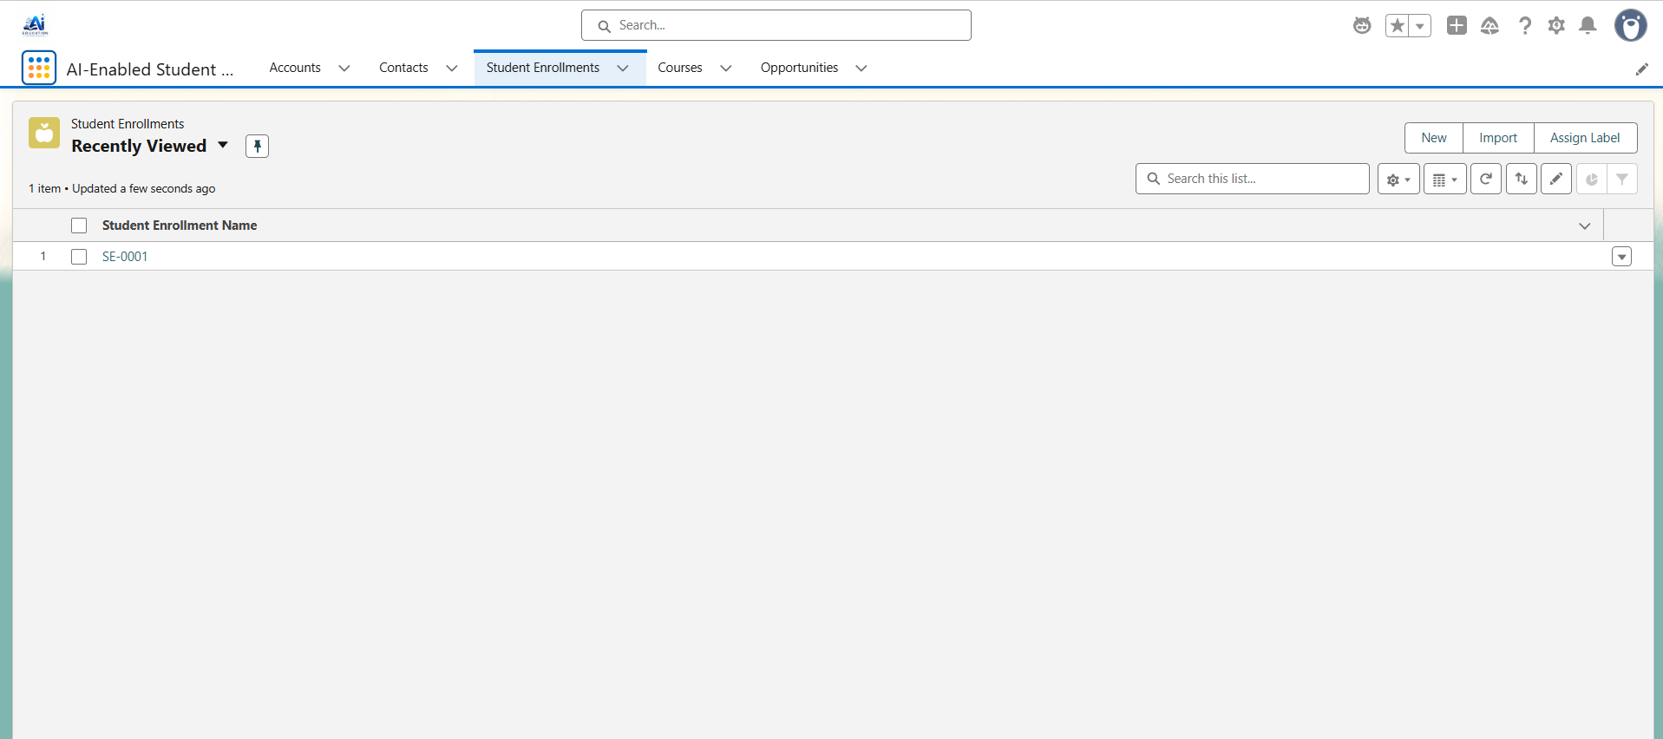
Phase 2 – Salesforce Development & Backend Configuration ... Custom Objects Student_Enrollment__c A custom object named Student_Enrollment__c was created to manage the complete enrollment lifecycle. Purpose: - Student details - Course details - Enrollment date - Approval status - Payment status - AI priority score - Risk level - Discount percentage
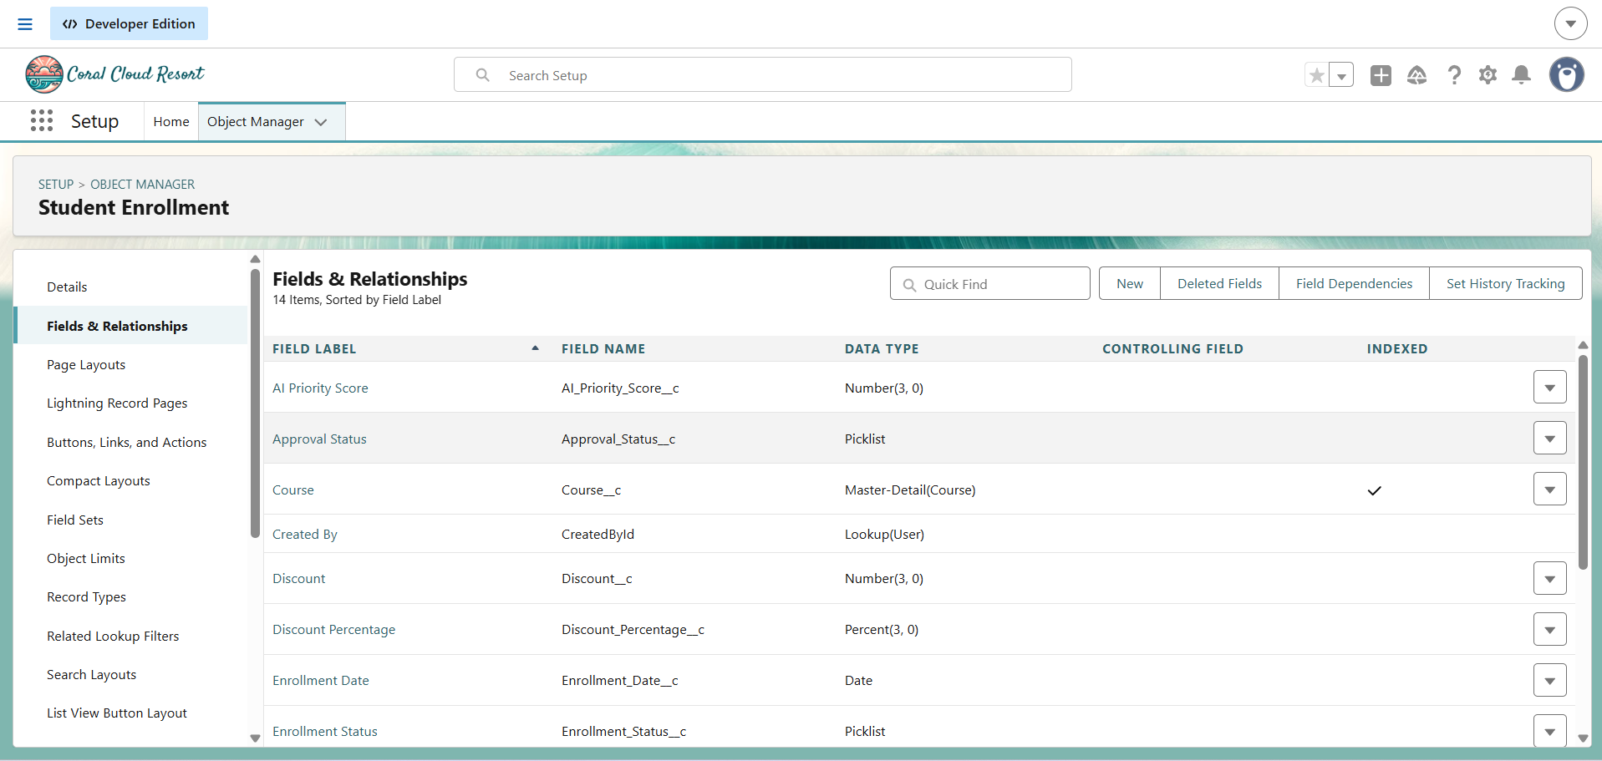
Custom Fields Several custom fields were configured to capture admission-specific information. Important fields include: - Student - Course - Enrollment Date - Enrollment Status - Approval Status - Payment Status - Discount Percentage - AI Priority Score - Risk Level - Discount
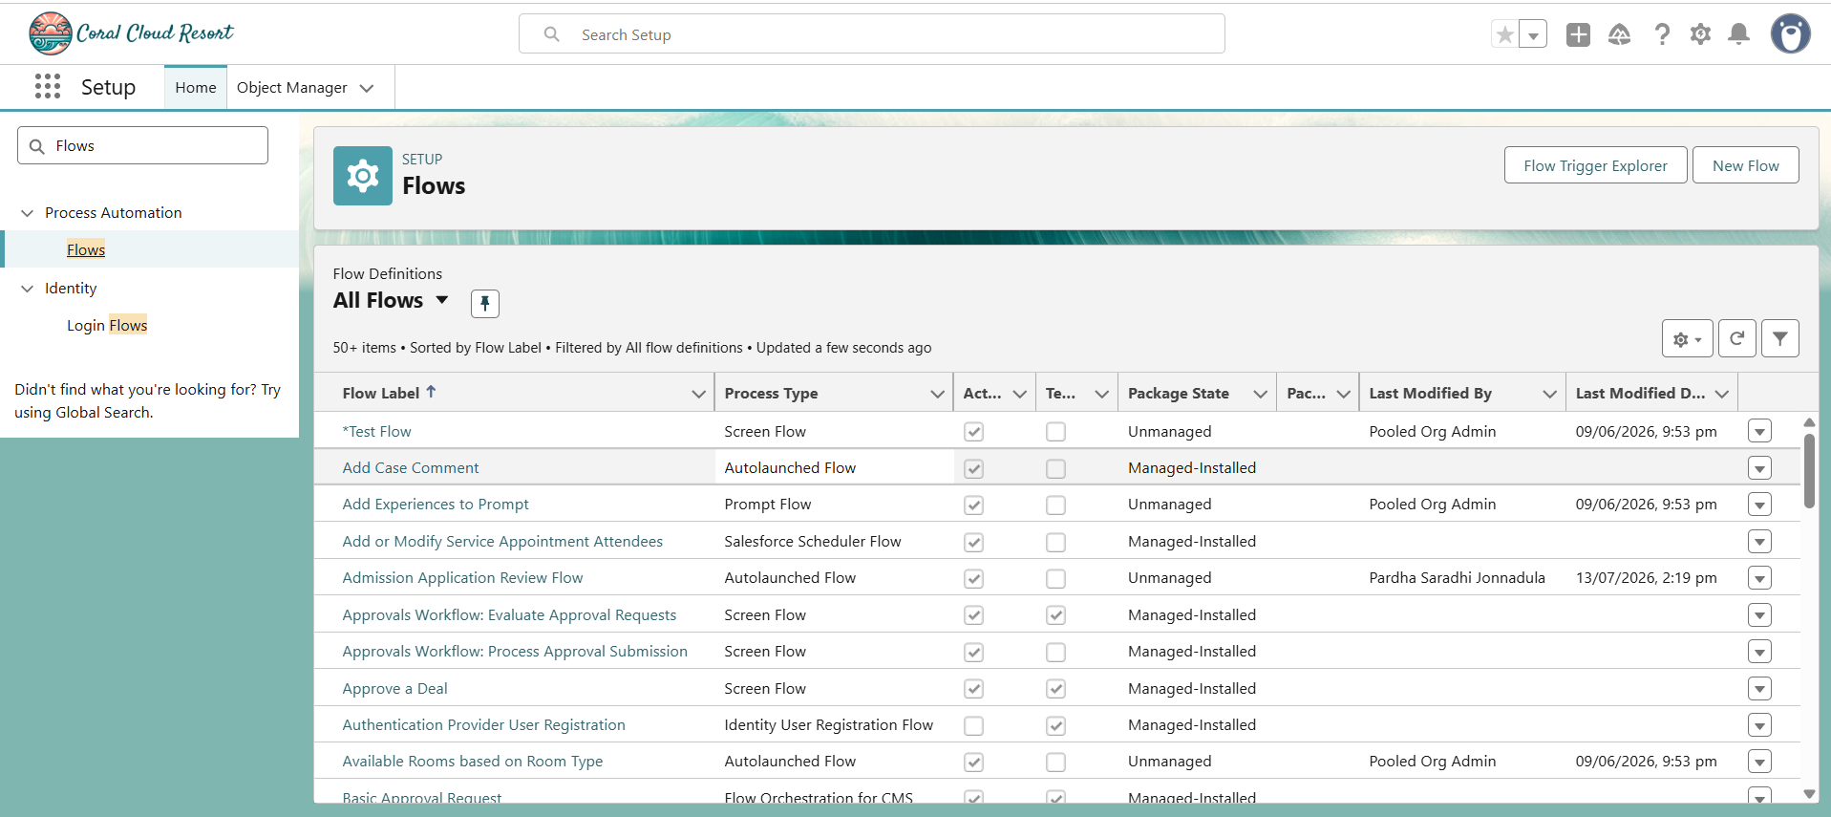
Automation Using Salesforce Flows Salesforce Flow Builder was used to automate repetitive admission activities. The following Flow types were implemented: - Record-Triggered Flow - Scheduled Flow - Screen Flow
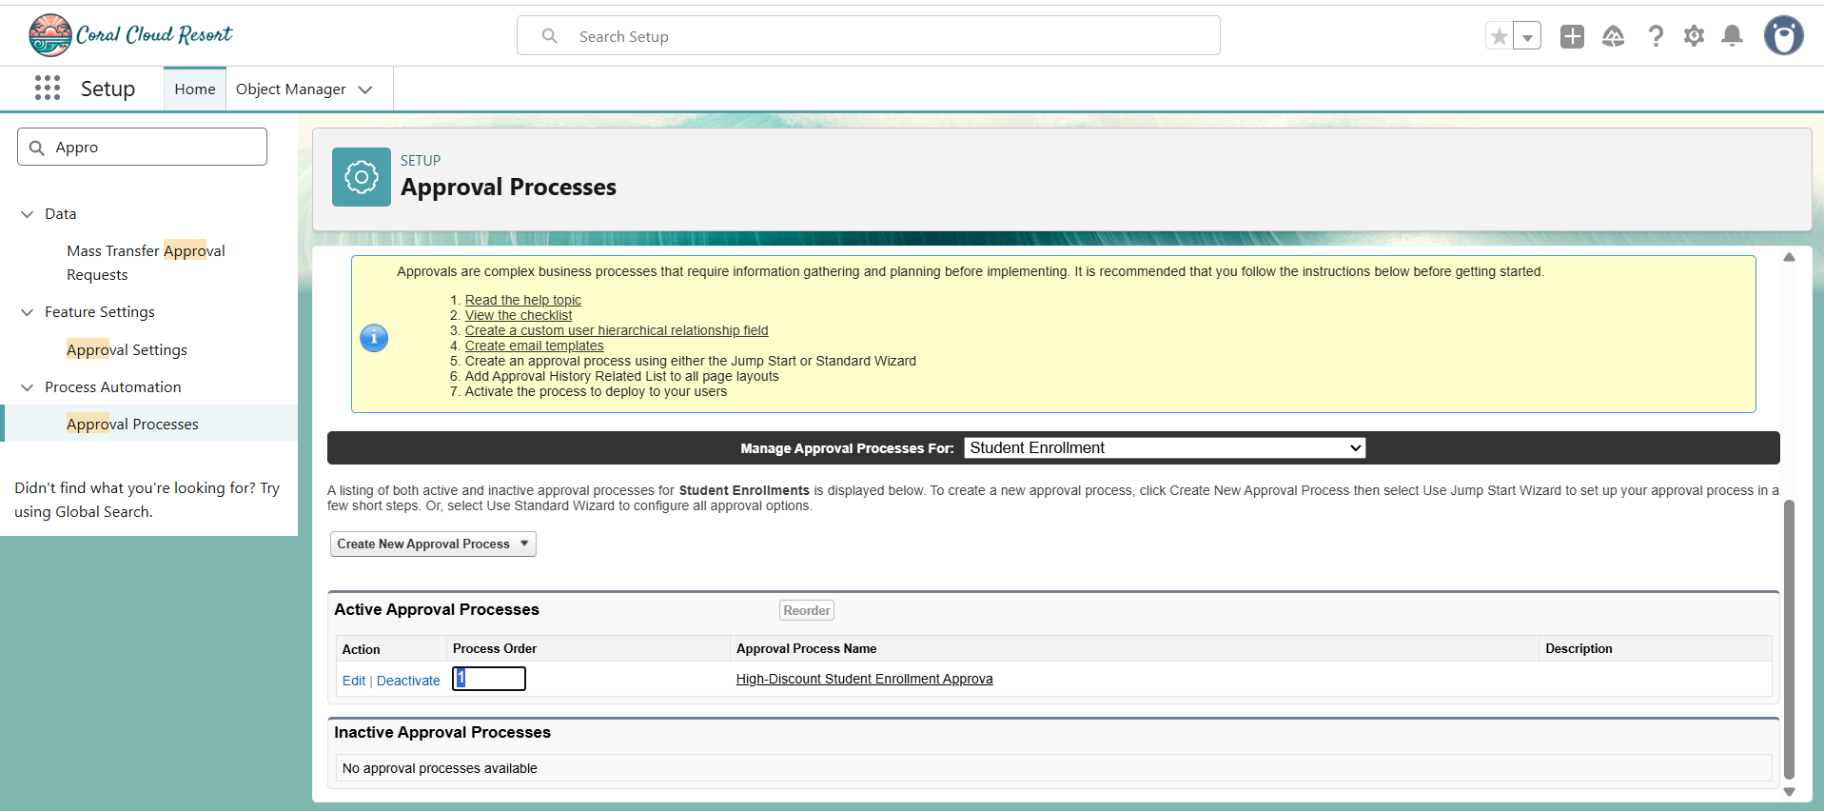
Approval Process An Approval Process was configured to automate admission approval activities. The Approval Process supports: - High discount approval requests. - Admission approval workflows. - Multi-level decision making
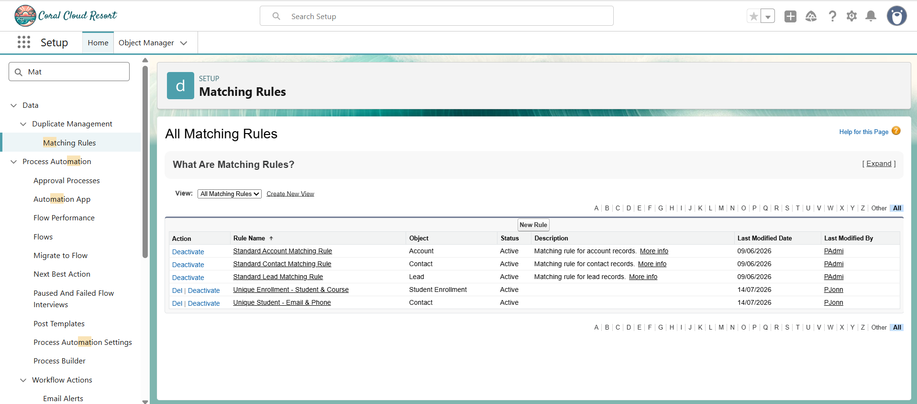
Matching Rules Matching Rules were created to identify duplicate records before they are saved. The following Matching Rules were configured: Contact Matching Rule Checks: - Email - Phone Number Purpose: Prevent duplicate student records. Student Enrollment Matching Rule Checks: - Student - Enrollment related fields Purpose: Reduce duplicate enrollment entries.
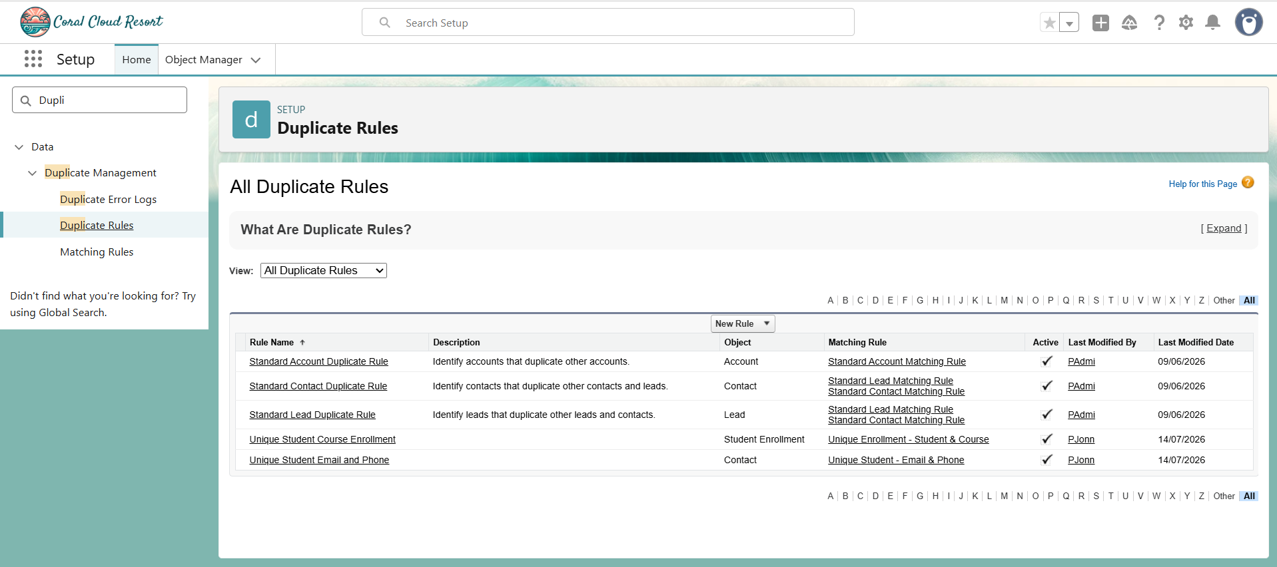
Duplicate Rules Duplicate Rules were configured to work together with Matching Rules. The following Duplicate Rules were implemented: - Unique Student Email and Phone - Unique Student Enrollment These rules help maintain clean and accurate admission data.
- Phase 2 Summary
During this phase, the backend of the AI-Enabled Student Admissions & Support Management System was successfully configured using Salesforce CRM. Custom objects, automation, approval workflows, duplicate management, and AI components were integrated to create a scalable and efficient admission management solution.
Phase 3 – UI/UX Development & Customization
Introduction
The UI/UX Development & Customization phase focused on creating a simple, user-friendly, and efficient interface for users of the AI-Enabled Student Admissions & Support Management System.
The objective of this phase was to convert backend Salesforce configurations and AI capabilities into an easy-to-use interface for Admission Counselors, Admission Managers, and Administrators.
The user interface was customized using Salesforce Lightning Experience components such as Lightning Apps, Page Layouts, Lightning Record Pages, and Dynamic Forms.
Lightning Application Creation
A dedicated Lightning Application was created for managing student admissions.
Application Name
AI-Enabled Student Admissions & Support Management System
Purpose
The Lightning App provides a centralized workspace where users can access all admission-related information and perform daily operations efficiently.
Navigation Items Added
The following items were added to the application:
- Accounts
- Contacts
- Student Enrollment
- Course
- Opportunity
This allows users to quickly navigate between important admission records.
Page Layout Customization
Page Layouts were customized to improve the visibility and organization of admission information.
The following objects were configured:
Student Enrollment Layout
The layout was customized to display:
- Student Information
- Course Information
- Enrollment Date
- Discount Details
- Approval Status
- Payment Status
- AI Priority Score
- Risk Information
This helps counselors and managers quickly understand student enrollment details.
Course Layout
The Course page layout was customized to display:
- Course Name
- Course Details
- Related Enrollment Information
This helps administrators maintain course-related information.
Account Layout
The Account layout was configured to organize organization-related details and related records.
Contact Layout
The Contact layout was customized to manage student information including:
- Student details
- Contact information
- Related enrollments

Opportunity Layout
The Opportunity layout was configured to track admission-related opportunities and progress.
Lightning Record Pages
Lightning Record Pages were created to provide a modern Salesforce user experience.
The pages were designed to display important information clearly and reduce unnecessary navigation.
The record pages provide:
- Student details
- Enrollment information
- AI-related insights
- Related records
Dynamic Forms Configuration
Dynamic Forms were enabled to improve record page flexibility.
Dynamic Forms allow fields to be displayed directly as individual components instead of using a traditional page layout section.
Benefits:
- Better field visibility
- Improved user experience
- Easier page customization
- Role-based information display
Important AI fields displayed:
- AI Priority Score
- Risk Level
- Discount Recommendation
User Experience Improvements
The interface was designed according to the requirements of different users.
For Admission Counselors
The interface provides:
- Quick access to student records
- AI priority information
- Enrollment status
- Follow-up activities
For Admission Managers
The interface provides:
- Approval information
- Discount details
- Risk analysis
- Enrollment overview
For Administrators
The interface provides:
- System management options
- User management
- Configuration access
UI Security Considerations
The user interface was aligned with Salesforce security settings.
Access was controlled using:
- Profiles
- Roles
- Object Permissions
- Field-Level Security
This ensures that users can only view and modify the information required for their responsibilities.
Benefits of UI/UX Customization
The customized Lightning interface provides:
- Faster access to admission records.
- Improved user productivity.
- Better visibility of AI insights.
- Reduced navigation complexity.
- Enhanced decision-making.
- A modern Salesforce user experience. 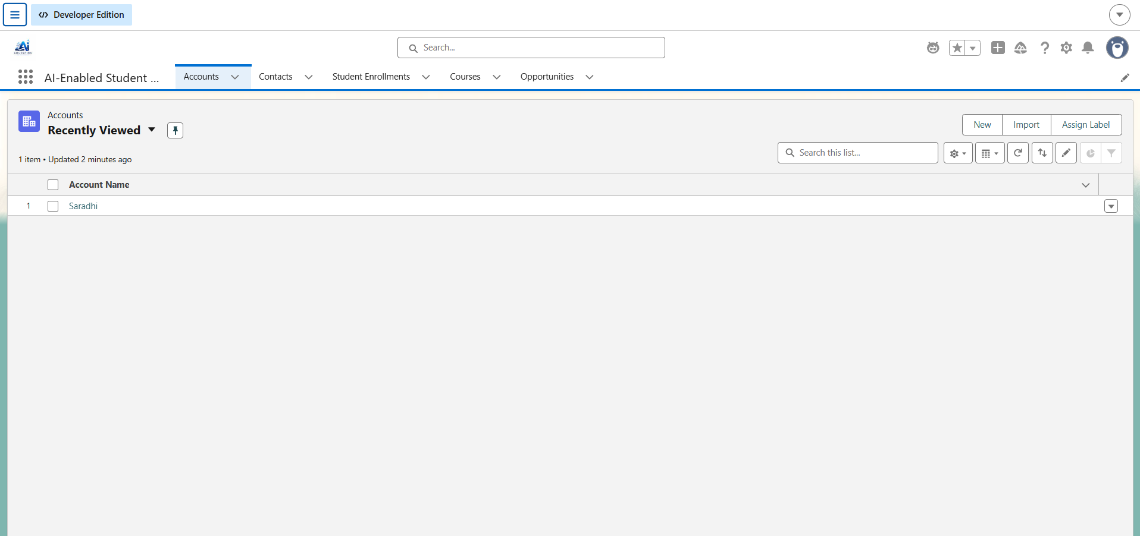
- # Phase 3 – UI/UX Development & Customization

- Introduction
- ............

- Lightning Application Creation

- A dedicated Lightning Application was created for managing student admissions.

- Application Name:
- AI-Enabled Student Admissions & Support Management System

- Purpose:
- The Lightning App provides a centralized workspace...
- 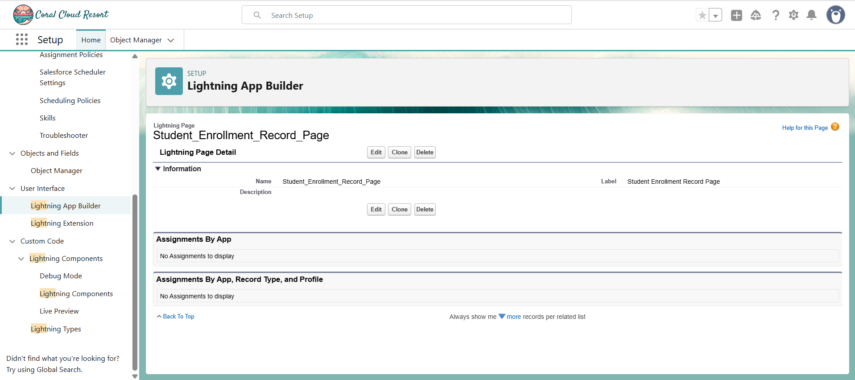
- Lightning Record Pages Lightning Record Pages were created to provide a modern Salesforce user experience. The pages were designed to display important information clearly. The record pages provide: - Student details - Enrollment information - AI-related insights - Related records - User actions
- Phase 3 Summary
The UI/UX Development & Customization phase successfully transformed the Salesforce backend configuration into an intuitive and productivity-focused interface. Lightning Apps, Page Layouts, Record Pages, and Dynamic Forms were configured to provide a seamless experience for admission teams.

Phase 4 – User Management & Security Configuration
Introduction
The User Management & Security phase focused on creating a secure Salesforce environment where different users can access admission data according to their responsibilities.
Salesforce security features such as Profiles, Roles, Users, Object Permissions, and Field-Level Security were configured to provide controlled access to the AI-Enabled Student Admissions & Support Management System.
User Roles Configuration
Roles were created to define the hierarchy and data visibility within the organization.
Admission Manager Role
The Admission Manager role was created to represent users responsible for reviewing applications, approving requests, and monitoring admission activities.
Responsibilities:
- Review student enrollments.
- Approve discount requests.
- Monitor admission progress.
- Analyze AI recommendations.
Admission Counselor Role
The Admission Counselor role was created under the Admission Manager role.
Responsibilities:
- Manage student applications.
- Create enrollment records.
- View AI Priority Scores.
- Perform student follow-ups.

Profile Configuration
- Profiles were created to control user permissions and access levels.
Admission Counselor Profile
This profile provides access required for daily admission operations.
Permissions provided:
Object Access
Read/Create/Edit access for:
- Contact (Student)
- Student Enrollment
- Course
- Task
Read-only access for:
- Reports
- Dashboards
AI Field Access
Read access provided for:
- AI Priority Score
- Risk Level
Restrictions:
- No approval permissions.
- No administrative override permissions.
Admission Manager Profile
This profile provides higher-level access for admission management activities.
Permissions include:
- Review student enrollments.
- Approve discount requests.
- Access admission insights.
- Monitor team activities.
User Creation
Users were created in Salesforce based on organizational roles.
Admission Counselor User
Configured with:
- Role: Admission Counselor
- Profile: Admission Counselor Profile
- User License: Salesforce
Responsibilities:
- Manage student records.
- Process enrollments.
- Perform follow-ups.
Admission Manager User
Configured with:
- Role: Admission Manager
- Profile: Admission Manager Profile
- User License: Salesforce
Responsibilities:
- Review approvals.
- Monitor admission activities.
- Make final decisions.
Security Configuration
Salesforce security settings were configured to protect student admission information.
Object-Level Security
Controls access to Salesforce objects.
Configured permissions for:
- Student Enrollment
- Contact
- Course
- Task
Field-Level Security
Controls visibility of individual fields.
Sensitive AI-related fields were protected based on user access.
Examples:
- AI Priority Score
- Risk Level
- Discount Information
Role-Based Access Control
Users can access records based on their organizational roles.
Benefits:
- Secure data sharing.
- Controlled access.
- Better data protection.
Password Policy Configuration
Security policies were configured:
- Password expiration: 90 days
- Minimum password length: 8 characters
- Session timeout configured for user security
- 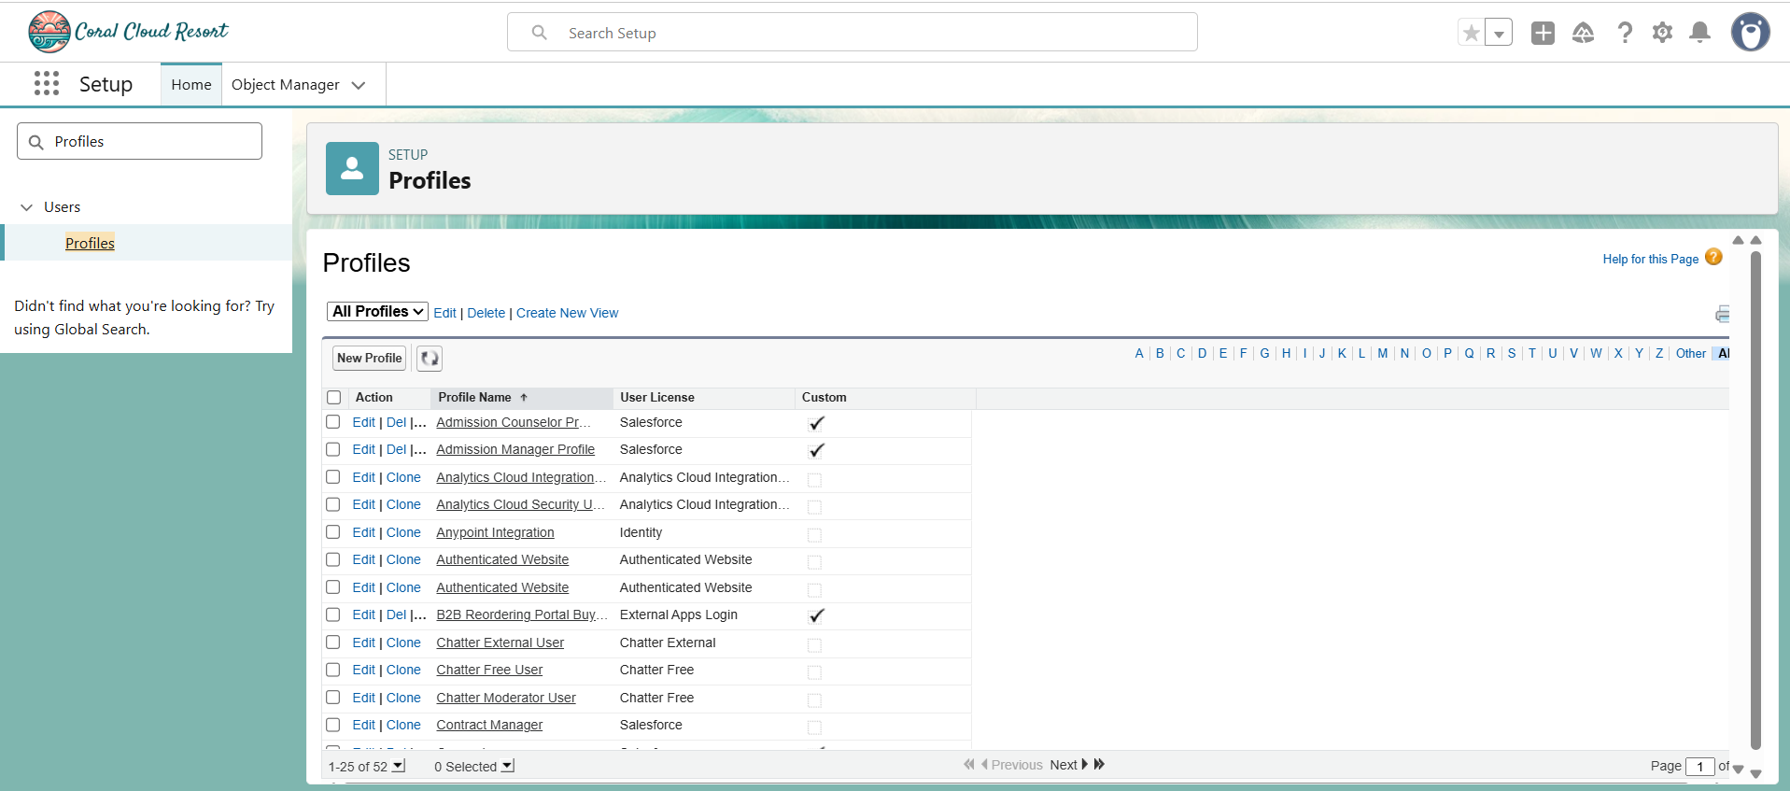
- Profile Configuration Profiles were created to control user permissions and access levels. Admission Counselor Profile This profile provides access required for daily admission operations. Admission Manager Profile This profile provides higher-level access for admission management activities.
- 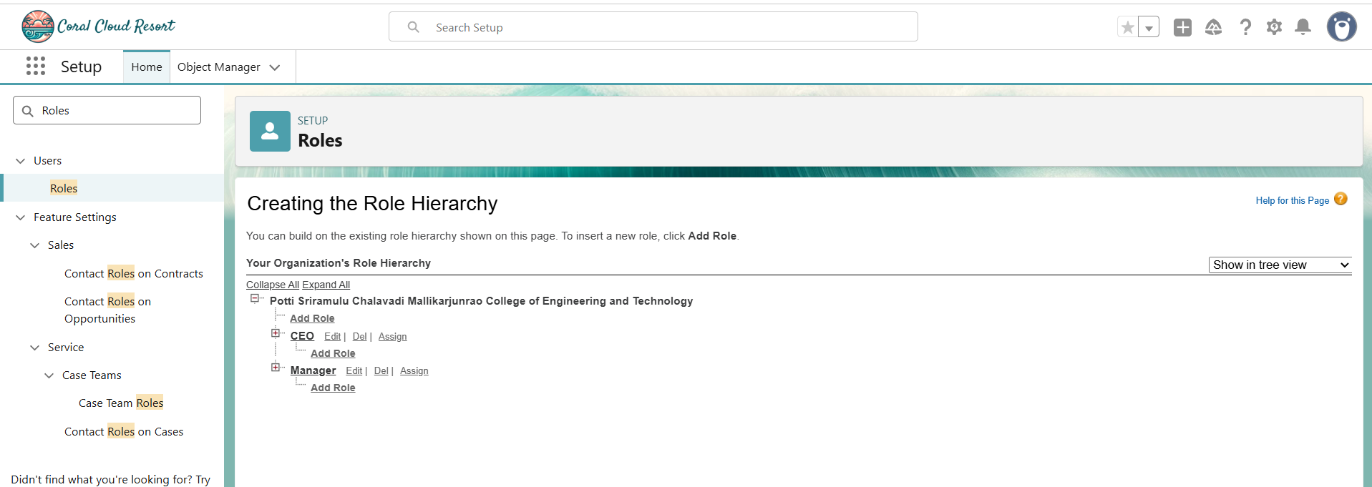
- User Roles Configuration Roles were created to define the hierarchy and data visibility within the organization. Admission Manager Role The Admission Manager role was created to represent users responsible for reviewing applications, approving requests, and monitoring admission activities. Admission Counselor Role The Admission Counselor role was created under the Admission Manager role.
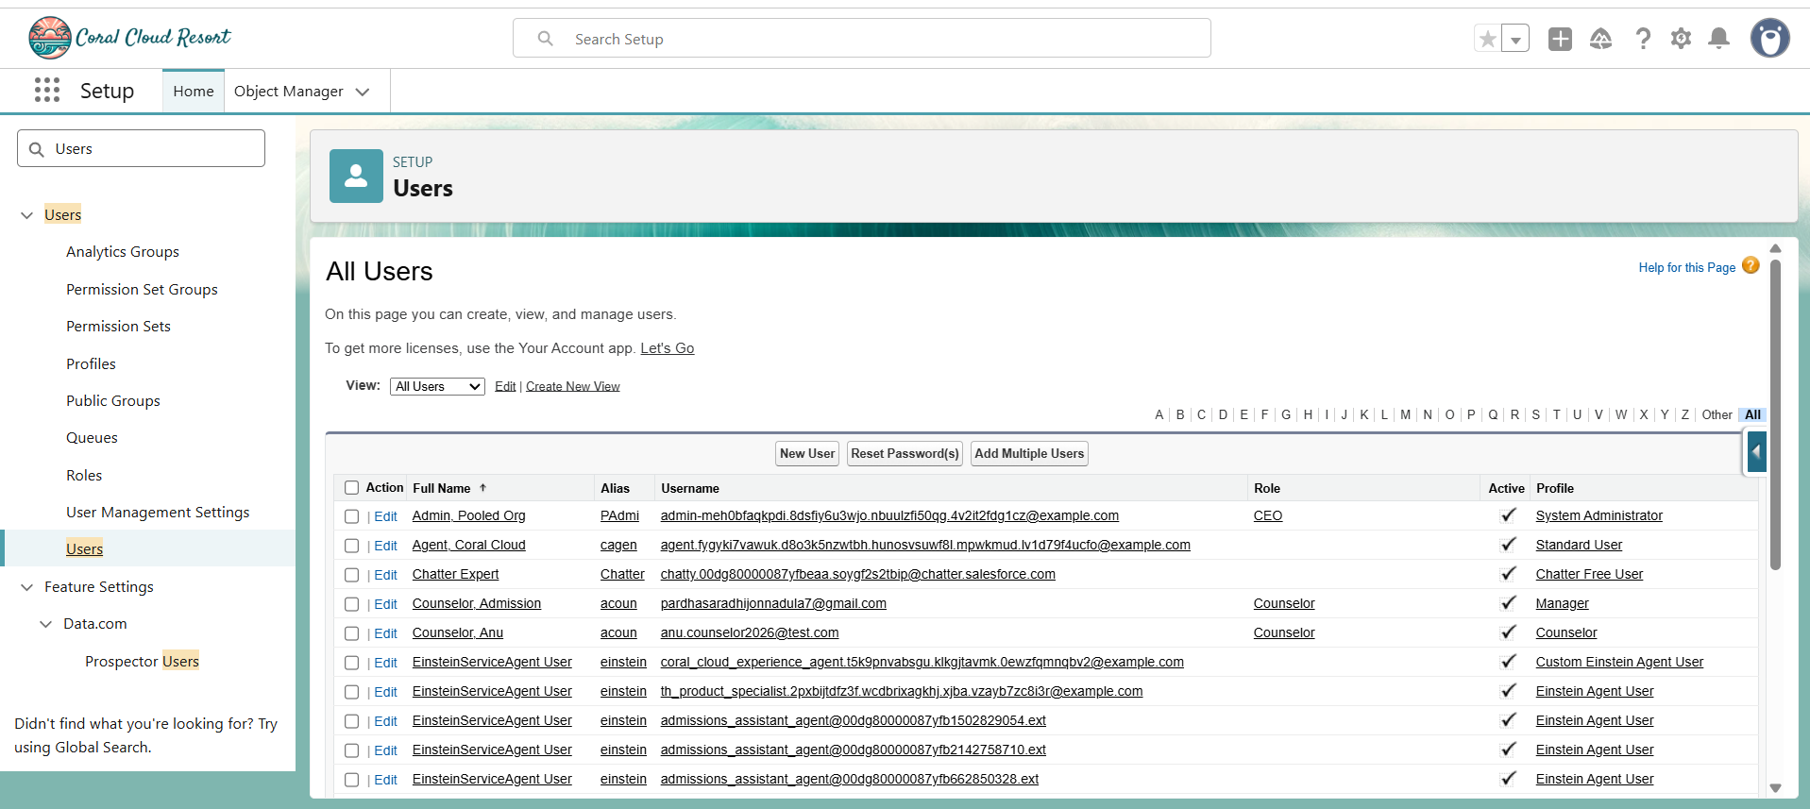User Creation Users were created in Salesforce based on organizational roles. Admission Counselor User Configured with: - Role: Admission Counselor - Profile: Admission Counselor Profile - User License: Salesforce Admission Manager User Configured with: - Role: Admission Manager - Profile: Admission Manager Profile - User License: Salesforce
- Phase 4 Summary
- The User Management & Security phase successfully established a secure Salesforce environment. Profiles, Roles, Users, and security permissions were configured to ensure that Admission Counselors, Admission Managers, and Administrators have appropriate access to perform their responsibilities while maintaining data confidentiality.
- Phase 5 – Deployment, User Training & Adoption
- Introduction
- The Deployment, User Training & Adoption phase focused on preparing the AI-Enabled Student Admissions & Support Management System for real-world usage.
- The objective was to validate system functionality, train users, monitor performance, and ensure successful adoption of the Salesforce solution.
Deployment Validation
Before final deployment, the following components were validated:
Salesforce Components
- Custom Objects
- Custom Fields
- Lightning Application
- Page Layouts
- Dynamic Forms
- Flows
- Approval Processes
- Email Alerts
- Profiles and Roles
- Agentforce configurations
Testing Activities
System testing was performed to ensure reliability.
Testing included:
Student Application Testing
Verified:
- Student record creation.
- Student information display.
- Enrollment process.
Enrollment Testing
Verified:
- Course selection.
- Enrollment creation.
- Status updates.
Duplicate Record Testing
Verified:
- Duplicate student detection.
- Duplicate enrollment prevention.
Approval Workflow Testing
Verified:
- Discount approval requests.
- Manager approval process.
- Approval status updates.
Automation Testing
Verified:
- Flow execution.
- Email notifications.
- Automated record updates.
- User Training
- Training was provided for different users.
Admission Counselor Training
Topics covered:
- Creating student enrollments.
- Viewing AI Priority Scores.
- Understanding recommendations.
- Managing follow-up tasks.
Administrator Training
Topics covered:
- Managing users.
- Maintaining Flows.
- Updating security settings.
- Monitoring AI features.

10. Flows & Approval Processes

Introduction
Salesforce automation plays an important role in reducing manual work and improving the efficiency of admission operations. In this project, Salesforce Flow Builder and Approval Processes were used to automate admission-related activities and improve decision-making.

Salesforce Flows
Record-Triggered Flow
A Record-Triggered Flow was configured to automatically perform actions when student enrollment records are created or updated.
Purpose
- Automate record updates.
- Maintain data consistency.
- Trigger admission-related actions.
- Reduce manual processing.
Example Actions
- Update enrollment status.
- Assign values automatically.
- Trigger notifications.
Scheduled Flow
A Scheduled Flow was configured to perform actions at a scheduled time.
Purpose
- Monitor pending applications.
- Send reminders.
- Track admission activities.
Benefits
- Reduces missed follow-ups.
- Improves workflow efficiency.
- Supports timely admission processing.
Screen Flow
A Screen Flow was used to provide a guided user experience.
Purpose
- Collect admission information.
- Simplify data entry.
- Improve user interaction.
Benefits
- Easy navigation.
- Reduced user errors.
- Better data collection.

Approval Process
An Approval Process was configured to manage admission approvals.

Purpose
The approval process helps Admission Managers review and approve important admission decisions.

Discount Approval Workflow
Process:
- Admission Counselor creates an enrollment record.
- Discount details are entered.
- Approval request is submitted.
- Admission Manager reviews the request.
- Request is approved or rejected.
Benefits of Approval Process
- Faster decision-making.
- Better control over approvals.
- Maintains approval history.
- Improves transparency.

11. Agentforce & AI Implementation

Introduction
Artificial Intelligence capabilities were integrated into the admission management system to support intelligent decision-making and improve admission efficiency.
Agentforce helps users access AI-powered recommendations and summaries directly within Salesforce.
AI Features Implemented
AI Priority Score
The AI Priority Score helps identify high-value student applications.
Benefits:
- Helps counselors prioritize applications.
- Improves response time.
- Supports better admission planning.
Risk Level Analysis
Risk analysis helps identify students who may require additional attention.
Benefits:
- Early identification of possible enrollment issues.
- Better student support.
- Improved retention planning.
Discount Recommendation
AI-based recommendations support managers while reviewing discount requests.
Benefits:
- Consistent decision-making.
- Reduced manual analysis.
- Better approval decisions.
Agentforce Capabilities
The system is designed to support Agentforce-powered admission assistance.
Student Application Summary
Provides summarized information about student applications.
Helps users quickly understand:
- Student details.
- Enrollment status.
- Important insights.

Enrollment Risk Analysis
- Provides AI-based analysis of possible enrollment risks.
- Helps admission teams take preventive actions.

Admission Recommendations
Provides intelligent suggestions to improve admission decisions.

12. Deployment Monitoring & Support
After deployment, continuous monitoring activities were performed to ensure system reliability and user satisfaction.
Monitoring Activities
The following areas were monitored:
AI Usage Monitoring
Tracked:
- Usage of AI priority scores.
- AI recommendations.
- User interaction with AI insights.
Enrollment Performance Monitoring
Reviewed:
- Enrollment conversion rates.
- Student application progress.
- Admission performance.
Automation Monitoring
Checked:
- Flow execution.
- Scheduled automation.
- Email notifications.
Support Activities
Support activities included:
- Resolving user queries.
- Collecting feedback.
- Improving system usability.
- Updating AI thresholds.
- Enhancing recommendation clarity.
- Improving UI labels and help text.
- 13. Business Impact & Outcomes
- The successful implementation of the AI-Enabled Student Admissions & Support Management System provided several business benefits.
- Faster Admission Processing
- Automation reduced manual activities and improved the speed of processing student applications.
- Better Student Prioritization
- AI Priority Scores helped admission teams focus on important and high-potential applicants.
Reduced Manual Effort
Flows and automation reduced repetitive tasks and improved productivity.
Improved Approval Efficiency
Approval workflows provided faster and more controlled decision-making.

Better AI-Assisted Decisions
AI insights helped managers make informed admission and discount decisions.

Increased Team Productivity
The system improved collaboration between Admission Counselors, Managers, and Administrators.

14. Future Enhancements
The system can be enhanced further with additional Salesforce and AI capabilities.
Future improvements include:
- Advanced predictive AI models.
- Student chatbot integration.
- Automated student communication.
- Mobile admission application.
- Advanced analytics dashboards.
- AI-based enrollment forecasting.
- Integration with external education platforms.

15. Conclusion
The AI-Enabled Student Admissions & Support Management System successfully demonstrates how Salesforce CRM, automation, and Artificial Intelligence can be combined to improve the student admission process.
The project provides a centralized platform for managing student applications, enrollment workflows, approvals, and AI-driven recommendations.
By implementing Salesforce Lightning, Custom Objects, Flows, Approval Processes, Profiles, Roles, and Agentforce capabilities, the system improves operational efficiency, enhances decision-making, ensures secure access, and provides a scalable solution for future educational requirements.

